**PROJECT REPORT**

**ON**

**LIBRARY MANAGEMENT SYSTEM**

*A report submitted in partial fulfilment of the need for the award of*

*The degree of*

**MASTER OF COMPUTER APPLICATION**

**Submitted to:**

DR. PRIYANKA DAHIYA

ASSISTANT PROFESSOR

**Submitted by:**

ROHIT SINGH GUSAIN(195339930)

DEEPAK RAWAT(195339934)

CHARU JOSHI(195339935)

AJAY(195339939)

**SCHOOL OF COMPUTING**

**DIT UNIVERSITY, DEHRADUN**

(State Private University through State Legislature Act No. 10 of 2013 of Uttarakhand and approved by UGC)

**Mussoorie Diversion Road, Dehradun, Uttarakhand - 248009, India.**

**2020**

**CANDIDATES DECLARATION**

I hereby certify that the work, which is being presented within the Report, entitled **LIBRARY MANAGEMENT SYSTEM**, in partial fulfilment of the need for the award of the Degree of **MASTER OF COMPUTER APPLICATION** and submitted to the DIT University is an authentic record of my work carried out during the period **17-Aug-2020**to **30-Nov-2020**under the guidance of **DR. PRIYANKA DAHIYA.**

**Date:04-Nov-2020 Signature of the Candidates**



Rohit Singh Gusain



Ajay



Deepak Rawat

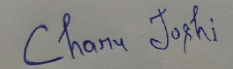 Charu Joshi

**DECLARATION**

This is to certify that the Project entitled “**LIBRARY MANAGEMENT SYSTEM",** in partial fulfilment of the requirement for the award of the Degree of **Master of** **Computer Application,** submitted to the DIT University, Dehradun, Uttarakhand, INDIA, is an authentic record of bonafide work carried out by **ROHIT SINGH GUSAIN(195339930), DEEPAK RAWAT(195339934), AJAY(195339939), CHARU JOSHI(195339935)** under my supervision and guidance.

**Date:04-Nov-2020 Signature of the Guide**

Dr. Priyanka Dahiya

**ACKNOWLEDGEMENT**

This project has been completed with the effort of all the group members, even though we faced a little bit problems. Finally, we are able to adapt it properly and wisely.

Besides this, we would like to thank our Project Mentor **Dr. Priyanka Dahiya** for his continuous support and encouragement. Whenever we needed him, he was always there behind us. This project wouldn't are completed without his guidance.

Finally, we would like to place a warm gratitude to all those who helped and carefully supported us. All the guidance and support received from all the members who contributed for this project, is vital for the success of this project.

**ABSTRACT**

The purpose of Library Management System is to automate the existing manual system by the help of computerized equipment and full-fielded computer software, fulfilling their requirements, so that their valuable data/information can be stored for a longer period with ease of accessing and manipulation of data. The required software and hardware are easily available and straightforward to figure with.

Library Management System is a error free secure, reliable and fast management system. It can assist the user to consider their other activities rather to consider record keeping. Thus it'll help organization in better utilization of resources. The organization can maintain computerized records without redundant entries. That means one need not to distract by information that is not relevant, while being able to reach the information.

**TABLE OF CONTENT**

**CHAPTER**

Candidate’s Declaration

Certificate

Acknowledgement

Abstract

1. Introduction 9

1.1Library Management System 9

1.2 Purpose: 9

1.3 Scope: 10

1.4 Definitions, Acronyms and Abbreviations: 11

1.5 Overview: 11

2. OVERALL DESCRIPTION 12

2.1 Product Perspective: 12

2.2 Product Functions: 12

2.3 Operating Environment: 13

2.4 Constraints: 13

2.5 System Study 13

PROPOSED SYSTEM 13

SYNOPSIS 14

Objectives: 14

Users Views: 15

Software Requirements: 15

Hardware Requirements: 15

FEASIBILITY ANALYSIS 15

Economical Feasibility 15

Technical Feasibility 15

DRAWBACKS OF PRESENT SYSTEM 16

BENEFITS 16

Development Tools 17

HTML…………………………………………………………………………………………17

CSS. 18

PHP (HYPERTEXT PREPROCESSOR): 18

MY-SQL (BACKEND): 18

Apache: 19

XAMPP: 19

2.5.1Communication Interfaces 20

2.5.2 Memory Constraints 20

2.5.3 Operations 20

2.5.4 Site Adaptation Requirements 20

2.6 Product Functions 20

2.7. User Characteristics 21

2.8 Assumptions and Dependencies 22

3.SPECIFIC REQUIREMENTS 23

3.1 External Interface Requirements: 23

3.2 Functional Requirements 23

3.3 Performance Requirements 24

3.4 System Analysis 24

3.5 Software System Attributes 24

3.5.1 Reliability 25

3.5.2 Availability 25

3.5.3 Security 25

3.5.4 Maintainability 25

3.5.5 Portability 26

3.6.Organizing the specific Requirements 27

3.6.1 System Mode 27

3.6.2 User Class 27

3.6.3 Objects 27

3.6.4 Feature 27

3.6.5 Stimulus 27

3.6.6 Response 27

3.6.7 Functional Hierarchy 28

4.System Design 29

Screenshots 30

5.References.................................................................................................................................38

**1.Introduction**

**1.1 Library Management System:**

The Library Module will store the information of all the books and members information It includes book title, book ID, and author name. This system also provide the search option through which we can search the book by its name or from its ISBN number.. Search function will search to database and will fetch the book if it is available in the database, it also tells the amount of book present. The user can also reserve the book , the reserve is validate only 3 days.

Only the administrator have the authority to edit the data base.

Administrator will handle administrative functions such as giving authority that at a time how many books a student can borrow , creating new user account ,activate/block user’s account and deciding the amount of fine for the borrowed books. User should enter the correct password and user id before can accessing these function.

Based on present method, librarian needs to record the entire booklist and borrower list manually using a logbook. This manual system is currently misspend time and might cause mistakes while recording process. The library’s inventory such as books is always changes within certain time because of additional or lost of those inventories.

With the present manually system, the monitoring process for this inventory become complicated.

With the Library Management System, the librarians are able to monitor and manage library’s inventory much easier and more efficient. There is large amount of database to support the future needs and will give added advantages to the all library operations.

## 1.2 Purpose:

The main purpose of Library Management System is to reduce the paper work and to manage library daily operation more efficiently. This system basically has 8 types of modules: Reserve book, Add book, Book Issue, User Module, Book details, Registration, Add Publication and Add Author.

The main motive behind library management system is to reduce two major problems:

* The student does not have to visit the library to check if the required book is available or not.
* Searching of any book become very easy and fast.

Now with just a click of mouse the user can search or get the details about any book.. This library module also created to ensure that the library items store properly in order to maintain their security.

The purpose of the application are as written below :

• To reduce the paper work.

• It provides following facilities to -

Operator:

• Can enter details regarding to a particular book.

Admin:

• Can read and write information about any user.

• Can update, create or delete the record of users as per requirement.

## 1.3 Scope:

## Earlier approach of maintaining the record of all the book is a tedious job for the librarian.. Library Information system will keep records of all the users including their background information .So that the users can know the details of their accounts, availability of books.

## 

## 1.4 Definitions, Acronyms and Abbreviations:

* **SRS:** System requirement Specification
* **Administrator:** A Login Id representing the user is an administrator & can access all the records details.
* **WWW:** World Wide Web
* **LMS:** Library management system.

## 1.5 Overview:

It gives an overall description of the software. It gives what level of proficiency is expected of the user and some general constraints while making the software.

It tells about specific requirements which the software is expected to deliver. Some performance requirements and constraints are also given and deal with other Non-Functional Requirements.

The purpose of this documents is to present a detailed description of the SRS. It will explain the purpose and features of the software , the interfaces of the software, what the software will do, the constraints under which it must operates and how the software will react to external stimuli. This document is intended for both the developers of the software and the end user. Specific design and implementation details will be specified in a future document.

The Library management system has to handle multiple records of book and its maintenance was a very tough task. Earlier it was done through manual process. Hence there is a need to upgrade the system with a computer based information system that is Online Library Management System.

# 2.OVERALL DESCRIPTION

## 2.1 Product Perspective:

The main purpose of “The Online Library Management System” is to keep record of all the books which include the author name, number of books available and it also keep track on the user. Its user friendly interface make it more easy to operate.

Library Management System is a stand-alone product and is not dependent on the availability of other website. The system will also have an administrator who has full-fledged rights with regards to performing all actions related to control and management of the website.

## 2.2 Product Functions:

**There are two different users who will be using this product:**

* User who can view their details and can check the availability of each book.
* Administrator who can view and edit the details of any students or book’s record.
* **The features that are available to the Administrator are:**
  + - * An Administrator has full rights to access all the functionality of LMS.
      * Can create or block the account of any user.
      * Can edit the information of user into database.
      * Can make search for a specific student.
      * Can access all the records of the student.
      * Can add new Publication.
      * Can add new Author.
      * Can add new Books.
* **The features that are available to the student are:**
* User can login into the system.
* Can view his/her personal details.
* Can edit his/her personal details
* Can Reserve Book.
* Can view his issued books and dues details.

## 2.3 Operating Environment:

This product can run on any browser.

## 2.4 Constraints:

* Every user must have basic knowledge of operating the computer and web browser.
* All operations are in English so user must have basic knowledge of English.

## 2.5 System Study

System Study is a detailed study of the various operations performed by a system and their relationships within and outside of the system. Here the main question is what were problems exist in the present system? What step to be taken to solve out those problem? Analysis begins when a user or manager begins a study of the program using existing system.

**System study can be categorized into four parts.**

* Feasibility study
* Proposed System with objectives
* System planning and initial investigation
* Feasibility study

# PROPOSED SYSTEM

In our proposed system we have the provision for adding the details of the books by themselves.

Another advantage of the system is that it is very easy to edit the details of the books and delete a book when it found unnecessary.

Keeping record of individual books and user become very easy and convenient.

# SYNOPSIS

**Why library management system?**

Library Management System can be used by education institutes to keep track of books easily. It provides very quick result with so ease. The librarian can easily record and go through the history of individual library users. On the other hand , the library users can know the location and availability of a particular book faster than before. The library management system reduces the cost of management.

## Objectives:

The main objectives of Library Management Systems are:

1. To build a system that is able to keep records of each individual book and track users and a monitoring system that is able to monitor and manage all library operations efficiently.
2. To reduce the mistake that always happens during manual method.
3. To enter and preserve details of various issues and keep a track on their returns.
4. To store properly the library items in order to maintain their security.

1. To eliminate the paper-work in library.
2. To maintain record of issued books, book available, reserve book etc.

## Users Views:

* Administrator
* End User

**Operating Systems:** Microsoft Windows

**Technologies Used:**

* **Client Side:**HTML, CSS.
* **Server Side:** PHP
* **RDBMS(Back end):** MySQL

## Software Requirements:

* PHP 5.0
* APACHE XXAMP Server
* Visual Studio Code for Coding

## Hardware Requirements:

* 1GB Ram or Higher
* 20 GB HDD or Higher
* Network Connectivity

# FEASIBILITY ANALYSIS

Whatever we think need not be feasible .It is wise to think about the feasibility of any problem we undertake. Feasibility is the study of impact, which happens in the organization by the development of a system. The impact can be either positive or negative. When the positives nominate the negatives, then the system is considered feasible. Here the feasibility study can be performed in two ways such as technical feasibility and Economical Feasibility.

## Economical Feasibility

This application is economically feasible .The organization do not required to spend much money on the development of the system which is already available. The only thing is need to be done is making an environment for the development with an effective supervision. By just doing so, we can obtain the maximum usability of the corresponding resources .Even after the development, the organization will not be in condition to invest more in the organization. Therefore, the system is economically feasible.

## Technical Feasibility

This involves questions such as whether the technology needed for the system exists, how difficult it will be to build, and whether the firm has enough experience using that technology. This application is build on the technology of Php for the backend and Mysql for the database which is in current use. The application is in fact that it has been developed on Windows XP platform and a high configuration of 1GB RAM on Intel Pentium dual core processor. This is technically feasible.

# DRAWBACKS OF PRESENT SYSTEM

Some of the problems being faced in manual system are as follows:

1. Keeping record of individual book and user was a tedious job.

2. Keeping track of a book is difficult.

3. Keeping record about issue/return of the books are not properly

Maintained.

4. No central database can be created as information is not available in

Database.

# BENEFITS

Some benefits of using this application are:

* Provides user friendly graphical user interface which suits the user.
* Book can be searched in a very efficient time.
* Easily track the details of the user.
* Reduced paper work.
* Saves time.
* Maintain record of issued books, book available etc.
* Minimizes mistake that always happens during manual method.

# 

# Development Tools

**The tools used to develop include:**

HTML/CSS

PHP scripting language

MySQL database server

Apache server

Visual Studio Code for coding

# 

# HTML:

HTML stands for the Hypertext Markup Language, is the standard markup language which is used to create web pages. Along with CSS, and JavaScript, HTML is a used to develop web pages. Web browsers is used to interpret the HTML. HTML describes the structure of a website semantically along with cues for presentation, making it a markup language, rather than a programming.

HTML consist of various tags which are used to enhance the design of the web pages .We can also embed the images through HTML which can make the website more interactive. It provides a means to create structured documents by denoting structural semantics for text such as headings, paragraphs, lists, links, quotes and other items..

Browsers do not display the HTML tags, but use them to interpret the content of the page if we make our web page only with the help of html, then we can’t add many of the effective features in a web page, for making a web page more effective we use various platforms such as CSS.

# CSS:

CSS Stands for "Cascading Style Sheet." Cascading style sheets are used to format the layout of Web pages. They can be used to define text styles, table sizes, and other aspects of Web pages that previously could only be defined in a page's HTML. The basic purpose of CSS is to separate the content of a web document (written in any markup language) from its presentation (that is written using Cascading Style Sheets). There are lots of benefits that one can extract through CSS like improved content accessibility, better flexibility and moreover, CSS gives a level of control over various presentation characteristics of the document. It also helps in reducing the complexity and helps in saving overall presentation time. CSS gives the option of selecting various style schemes and rules according to the requirements and it also allows the same HTML document to be presented in more than one varying style

# PHP (HYPERTEXT PREPROCESSOR):

PHP is a server side scripting language and a powerful tool for making dynamic and interactive Web pages. PHP is a widely-used, free, and efficient alternative to competitors such as Microsoft's ASP.PHP started out as a small open source project that evolved as more and more people found out how useful it was. Rasmus Lerdorf unleashed the first version of PHP way back in 1994. Now it has version 4.0.3 with numerous improvements and refinements over the original release.

PHP is a server side scripting language that is embedded with the HTML. It is used to manage dynamic content, databases, session tracking, even build entire e-commerce sites. It is integrated with popular databases, including MySQL, PostgreSQL, Oracle, Sybase, Informix, and Microsoft SQL Server.

# MY-SQL (BACKEND):

MY-SQL is a database which follows RDBMS. MYSQL store the data in the form of rows and column. It is named after co- founder Michael Widenius's daughter. The SQL stands for Structured Query Language.SQL is a query based language which is used to perform the various operations in the database. The MySQL AB, now owned by Oracle Corporation .MySQL development project has made its source code available under the terms of the GNU General Public License, as well as under a variety of proprietary agreements.

MySQL was owned and sponsored by a single for-profit firm, the Swedish company. For proprietary use, several paid editions are available, and offer additional functionality.

# Apache:

The Apache HTTP Server is a web server software notable for playing a key role in the initial growth of the World Wide Web. Apache is developed and maintained by an open community of developers under the auspices of the Apache Software Foundation. For HTTP server the Apache is the most popular and useful software. In 2009 it became the first web server software to surpass the 100 million web site milestone.

# XAMPP:

Xampp is a light weight software which is used for the development of the web technology.It is widely used by students for developing and testing applications in PHP and MySQL. XAMPP is available as a free download in two specific packages: full and lite.

While the full package download provides a wide array of development tools, XAMPP Lite contains the necessary technologies that meet the Ontario Skills Competition standards. The light version is a small package containing Apache HTTP Server, PHP, MySQL, phpMyAdmin, Openssl, and SQLite.

### 2.5.1Communication Interfaces

The HTTP protocol will be used to facilitate communications between the client and server. The system supports Google Chrome and Mozilla Firefox web browsers.

### 2.5.2 Memory Constraints

Minimum memory of 512MB is required to run the exe file without any lags. This constraint does not possess an issue now a days as the minimum present RAM in common system is 1GB.

At least 512 MB RAM and 5 MB space on hard disk will be required for running the program.

### 2.5.3 Operations

The normal and special operations required by the user such as:

* The various modes of operations in the user organization
* Periods of interactive operations and periods of unattended operations
* Data processing support functions
* Backup and recovery operations

### 2.5.4 Site Adaptation Requirements

There should no site adaptation requirement since the Web Application Server was setup.

## 2.6 Product Functions

The website will allow access only to authorized users with specific roles (Administrator- maintains the website, Institutes-Register the users, Users-Fills the details).

Following are the System Functions:

**User role**

User have to put details like name, numbers, Email and password to be get register .User can also change their details later also

**Administration role**

The role of the administrator is to add records of book and keep track on the book.

## 2.7. User Characteristics

**End Users**

All specific knowledge or skills are required from the feeder.

* Skills: Users should have basic knowledge and should be comfortable.
* Experience: Users should have prior information regarding the library system.

Educational level: Users should be comfortable with the English language.

**Administrator**

Administrator must be capable to manage user rights.

This system will not take care of any virus problem, which might occur either on the Client or the server system. Avoiding the use of pirated software and ensuring that floppies and other removable media are scanned for viruses before use could minimize the possibility of viral infection.

**Constraints**

The Information of all users, subjects and allocations must be stored in a database that is accessible by every connected system. MySQL used for database.

Users may access from any system connected to the online database. Users must have their correct usernames and passwords to enter into their accounts.

## 2.8 Assumptions and Dependencies

The Software needs the following third party products-

* Sublime-text for development of project.
* XAMPP for database connectivity.

Although basic password authentication and role based security mechanisms will be used to protect OPMS from unauthorized access; functionality such as email notifications are assumed to be sufficiently protected under the existing security policies.

## 3.Specific Requirements

## 3.1 External Interface Requirements:

In this section we discuss about the provides a detailed description of all inputs into and outputs from the system. Provides us the description of the software, hardware, communication interfaces and provides the basic prototypes of the user interface.

User Interface**:**  the user interface will have the following fields for the user so that user can interact with the system.

1. Registration Screen: Various fields available on this screen will be:

* User-id(Auto-generated)
* Full Name
* Email Id
* Contact-no
* Dept
* Address
* Password
* Confirm-password
* Course

1. Login Screen: Various Fields are available in this page are:

* Email Id
* Password
* Verification Code

## 3.2 Functional Requirements

## In this we will talk about the functionalities which are required from the management system. The functionalities are as follows:-

* The website will help the colleges/organizations/companies and schools to conduct their user registration.
* Only authorized person can access related details.
* Organizations can change their information regarding themselves. The user can login through Email and Password.
* Administrator will be responsible for updating the site.

## 3.3 Performance Requirements

In this section we will discuss about the numerical requirements which we have made on the software or when the human interacts with the software, so the numerical requirement will include the following :

* Total no of 300 terminals will be supported at a time
* Only text information will be supported(HTTP)¬Online Student Registration.

## 3.4 System Analysis

In this section we will study in details about the various operations performed by the library system and their relationships with and outside of library system. What the question arises here is- what are the problems t exist in the present system? What must be done to solve the problem?

The analysis can be done when a manager or the user studies about the program using the existing library system.

## 3.5 Software System Attributes

We can have a number of attributes of software that can serve as requirements. It is important that required attributes by specified so that their achievement can be objectively verified. The following items provide a partial list of examples. These are also known as non-functional requirements or quality attributes. These are characteristics the system must possess, but that pervade (or cross- cut) the design. These requirements have to be testable just like the functional requirements. It’s easy to start philosophizing here, but keep it specific

### 3.5.1 Reliability

It deals on how the program performs with desired accuracy. The system which is developed must be reliable . The system must not be down for the users 2 times in a year.

### 3.5.2 Availability

The software will be available only to authorized users like user to view their details, admin to add an update/delete user details and book details. Checking that the system always has something to function and always pop up error messages in case of component failure. In that case the error messages appear when something goes wrong so to prevailing availability problems.

### 3.5.3 Security

The security requirements deal with the primarily security. The software should be handled only by the administrator and authorized users.

Only the administrator has right to assign permissions like creating new accounts and generating password.

Specific requirements in this area could include the need to:

* Utilization of certain type of cryptographic techniques
* Keeping the specific log or history of data sets
* Assigning functions to different modules of the system.
* Restriction of the communications between some areas of the program.
* Checking of the data for data integrity for critical variable.

### 3.5.4 Maintainability

The system should be designed in such a way that it is easily maintained. It must be very ease in a case to adapt new changes. In case of any mishap backups for database are available .

### 3.5.5 Portability

The web system application is programmed in PHP and My SQL. So it is made platform independent and is independent of Operating System. This system application will be portable easily on any window based operating system.

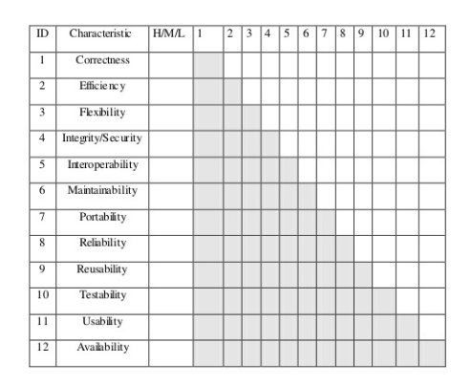**Characteristics of Library Management System**

* Correctness - Program satisfies specifications, fulfills user’s mission objectives
* Efficiency – The amount of computing resources and code required to perform function
* Flexibility – Ability to modify operational program ¬
* Interoperability - Ability to couple one system with another
* Reliability - Abilityto which program performs with required precision
* Reusability – Ability of program to be reused in another application
* Testability - Test to ensure performs as programed to.
* Usability - The required to learn, operate, prepare input, and interpret output.

## 3.6.Organizing the specific Requirements

For anything but trivial systems the detailed requirements tend to be extensive. For this reason, it is recommended that careful consideration be given to organizing these in a manner optimal for understanding. There is no one optimal organization for all systems. Different classes of systems lend themselves to different organizations of requirements in section 3. Some of these organizations are described in the following subclasses.

### 3.6.1 System Mode

Some systems behave quite differently depending on the mode of operation. When organizing by mode there are two possible outlines. The choice depends on whether interfaces and performance are dependent on mode

### 3.6.2 User Class

The user is the class that has all of the details of the users. System provide different functions to different classes of users.

### 3.6.3 Objects

Objects are real-world entities that have a counterpart within the system. Associated with each object is a set of attributes and functions.

These functions are also called processes ,methods, or services,. Note that sets of objects may share attributes and services. These are combined as classes.

### 3.6.4 Feature

A feature is an service provided by the system that may require inputs to get the desired result. Each feature is defined by a sequence of input/output pairs.

### 3.6.5 Stimulus

Systems can be defined by their functions in terms of stimuli.

### 3.6.6 Response

Systems can be defined by their functions in support of the generation of a response.

### 3.6.7 Functional Hierarchy

In case neither of the above organizational schemes prove helpful, the full functionality can be summed up into a hierarchy of functions organized by common inputs, common outputs, or common internal data access.The things that are used to show the relationships between and among the functions and data are DFD and Data Dictionary.

# 4. System Design

The purpose of designing the system is to create a solution. Which satisfies the functional requirements for the system. The lifecycle of the project should be a Functional Specification, written primarily in business terminology, containing a complete description of the operational needs of the various organizational entities that will use the new system.

The task of the system is to translate all of the information into Technical Specifications that accurately describe the design of the system, and that can be used as input to System Construction. The specification of the functions produced during analysis of System Requirements is transformed into a physical architecture. The components of the System are distributed across the physical architecture, usable interfaces are designed and prototyped.

The Specifications of the technical phase are created for the Developers of application, allowing them to build help in testing of the library system. Many of the organizations look at System Design primarily as the Preparation of the system component specifications; however, Construction of the various system components is only one of a major steps in successfully building a library system. The preparation of the environment needed to build the system, the testing of the system, and the migration and preparation of the data that will ultimately be used by the system are equally important

# Screenshots

#### Home Page:

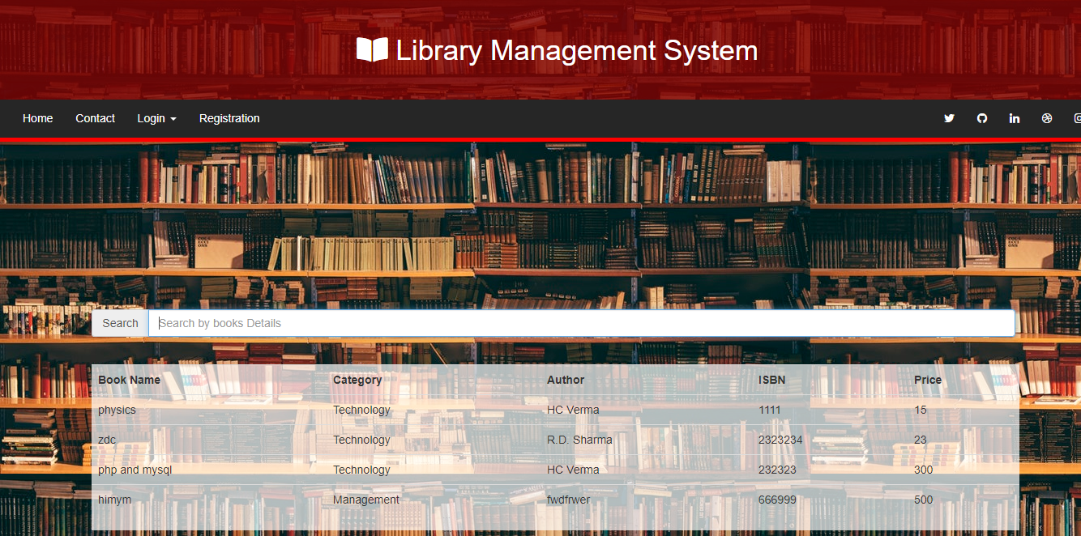

**REGISTER FORM:**

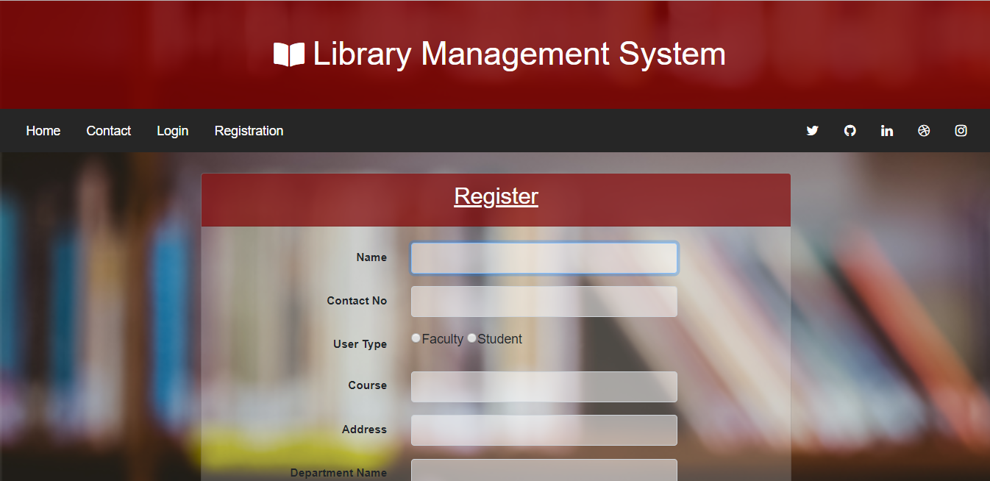

**If User Type Are Faculty Then Course Is Not Applicable:**

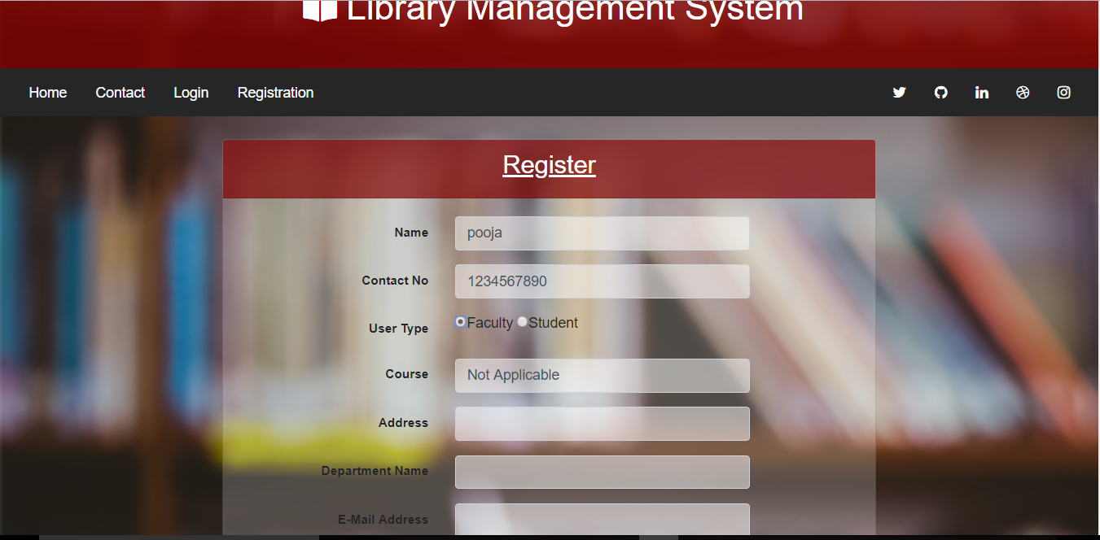

**If User Type Are Student Then Course Is Applicable:**

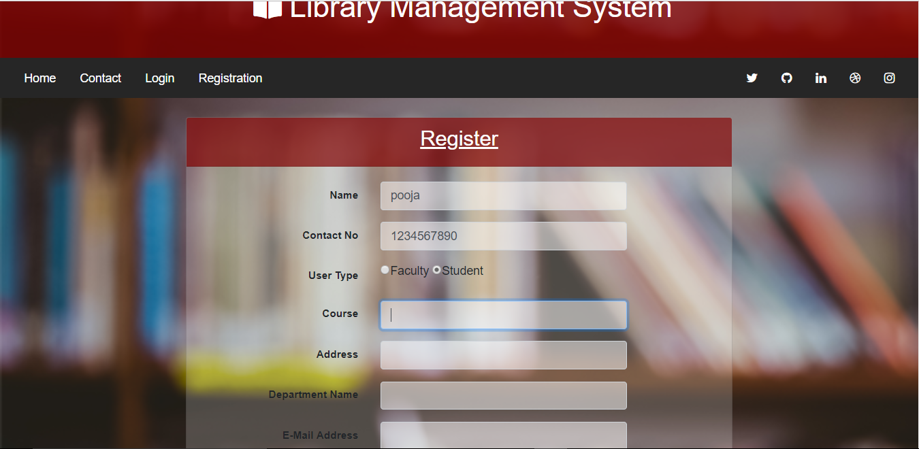

**Registration Form with Password Validation:**

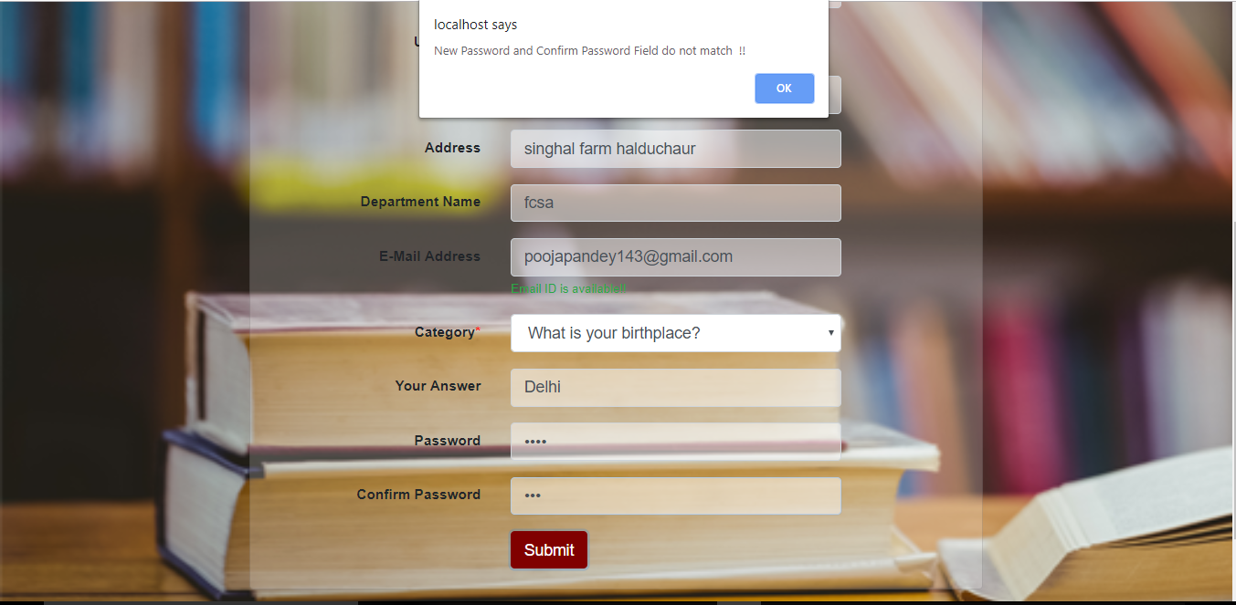

#### USER LOGIN FORM:

* Email ID and p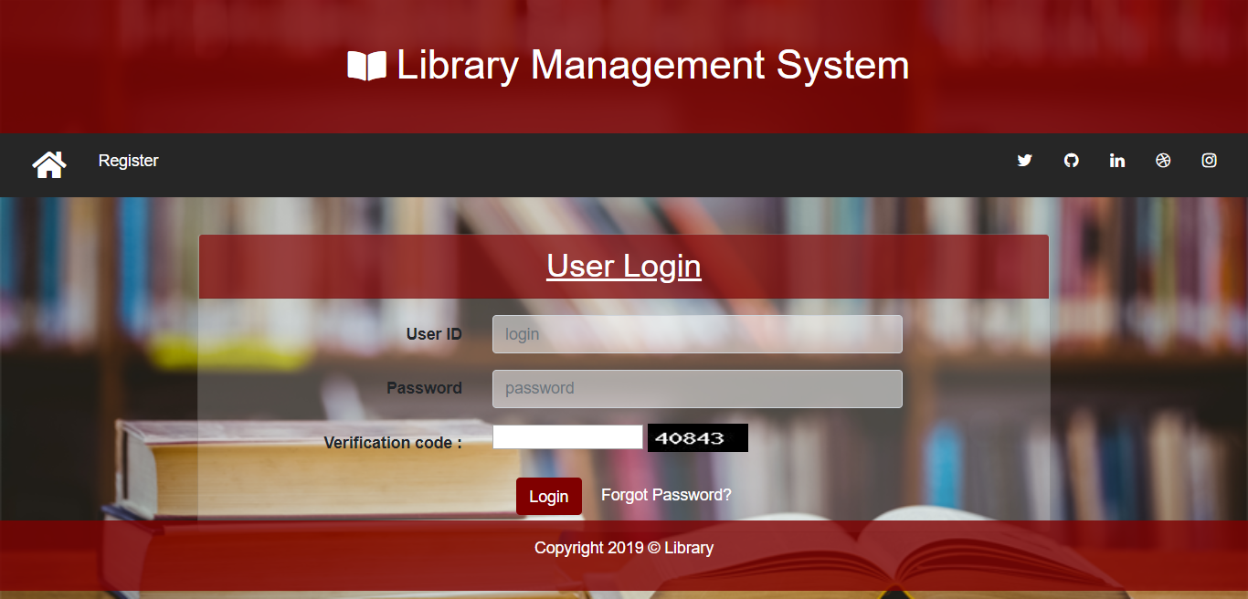assword is must for login.

**FORGOT PASSWORD FORM OF USER:**

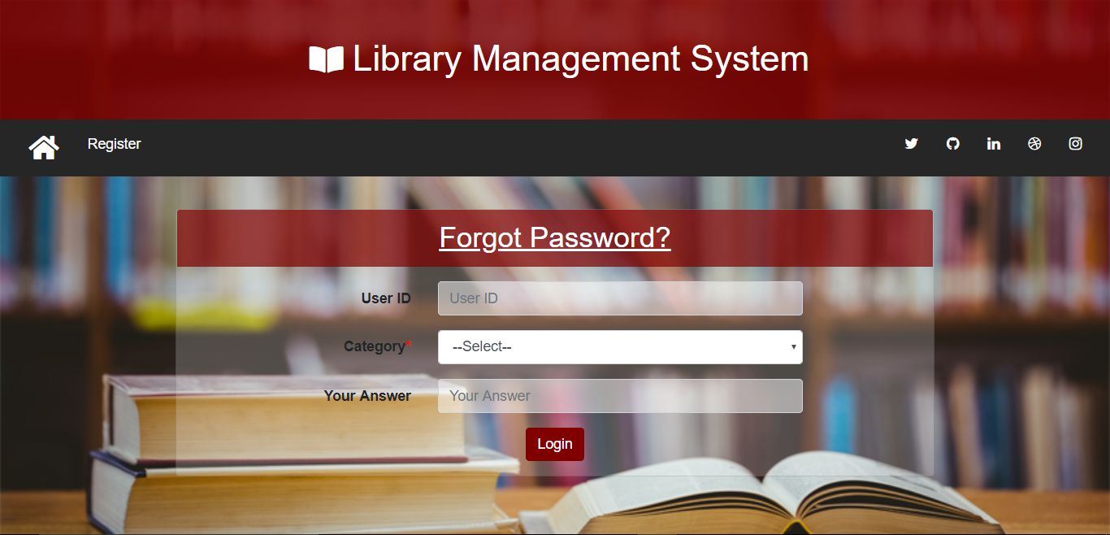

**USER DASHBOARD:**

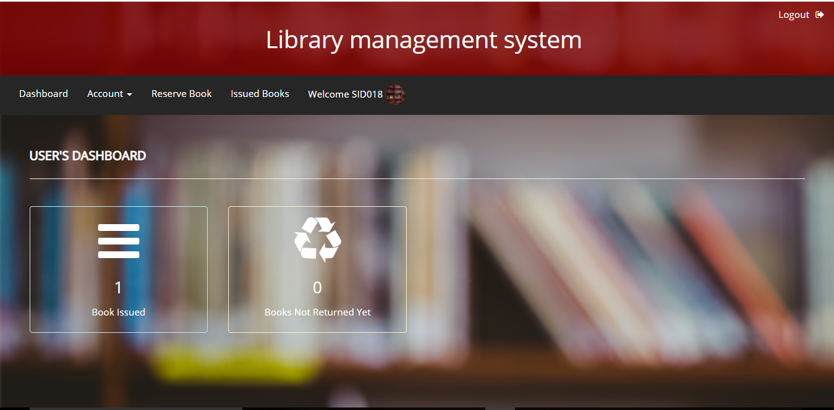

**ADMIN DASHBOARD:**

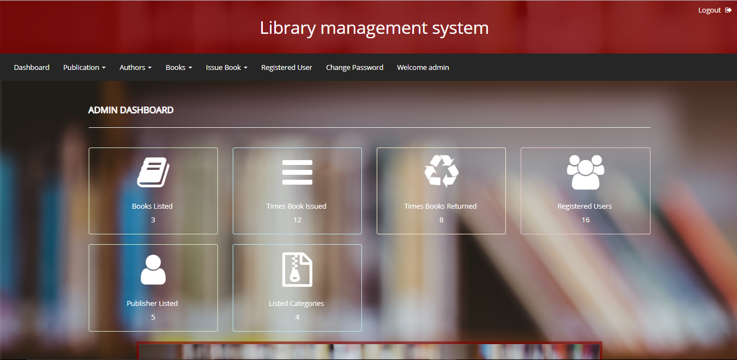

# 5.REFERENCES

**BOOKS**

1. Developing PHP Applications for IBM Data Servers Whei-Jen Chen, Holger Kirstein, Daniel Krook,Kiran H Nair, and Piotr Pietrzak

2. Programming PHP Rasmus Lerdorf, Kevin Tatroe

3. PHP 5 Power Programming Andi Gutmans, Stig Bakken, Derick Rethans

4. Practical PHP Programming Paul Hudson

**LINKS**

1. [www.w3schools.com/php/](http://www.w3schools.com/php/)

2. [www.stackoverflow.com](http://www.stackoverflow.com)

3.[www.google.com](http://www.google.com)

4.[www.wikipedia.com](http://www.wikipedia.com)

**PLAG REPORT**

**Submission date:** 10-Nov-2020 02:16PM (UTC+0530)

**Submission ID:** 1436770562

**Group ID:** MCA_G7